How to create Shared Folder:

Step 1:

Open VM, go to vm->settings

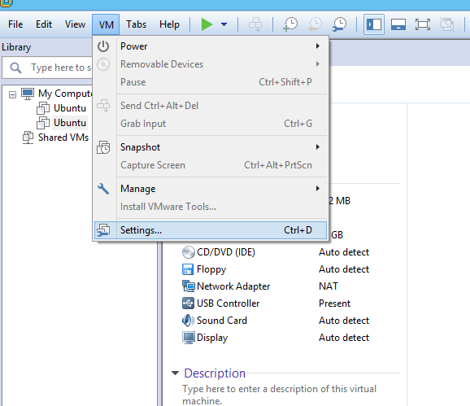

Step 2:

Go to options -> Shared Folders -> check “Always enable”

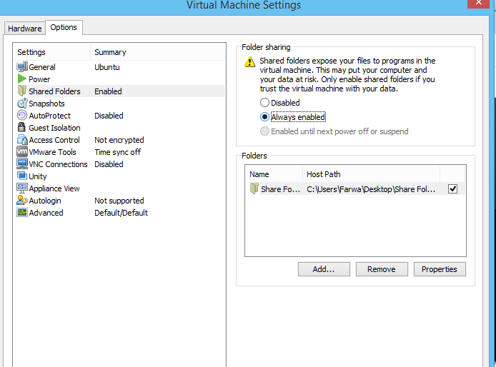

Step 3:

Add path of your share folder.

Step 4:

Open Ubuntu

Go to

File system -> mnt->hgfs -> shared folder

